No Waste Application Events

Conwell Maraya

Main Window

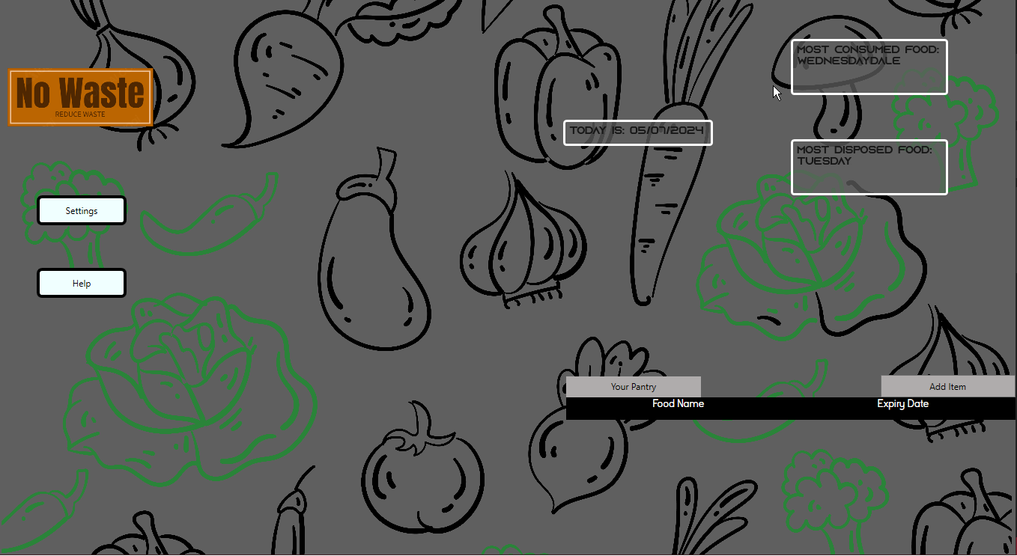

2

3

1

1. Opens the Settings Window
2. Opens the Help Window
3. Adds an Item to the Pantry Grid

Add Item Window

1

1. Adds the Given food item into the Pantry Grid. Given that the Food name Field is Filled

Item Window

3

2

1

1. Deletes the Given Food Item off the grid and adds it to the Consumed List file.
2. Deletes the Given Food Item off the grid and adds it to the Disposed List file
3. Closes the Popup

Settings Window

4

3

2

1

1.Opens the Pantry Text Color Picker

2.Opens the Pantry Color Picker

3.Color Picker for the Text Color

4. Color Picker for the Pantry Grid Background